



LABORATORY RECORD NOTE BOOK

AMITY UNIVERSITY CHHATTISGARH

LABORATORY MANUAL
A Lab Manual Submitted to

Amity University Chhattisgarh, Raipur (AUC)

In

Computer Science Engineering
By

Karri Amruthavarshini
(A80105223088)
Submitted to

Ms. Shikha Tiwari Associate Professor
Amity University Chhattisgarh, Raipur

Amity School of Engineering & Technology

Amity University Chhattisgarh, Raipur (AUC)
Manth / Kharora, (Opp.-ITBP) SH-09, Raipur, Chhattisgarh - 493225 (2023-24)


Amity University Chhattisgarh

Amity School of Engineering & Technology

Batch: 2023- 2027

Enrolment Number: A80105223088
This is to certify that this is a Bonafede record of the work done by Ms. Karri Amruthavarshini bearing enrolment number A80105223088 of B. Tech Computer Science & Engineering semester VI, from Amity School of Engineering & Technology, Amity University Chhattisgarh in the Data Science using Python Lab with Course Code DS4602

University Examination held on .

Facultyin-charge DirectorASET

Examiner- 1 Examiner-2

INDEX

Sl. No | Experiment | Date of Exp. | Date of Submission | Signature
1 | Demonstrate usage of branching and looping  statements? | 09/10/2025
2 | Demonstrate Recursive functions? | 09/10/2025
3 | Demonstrate Lists? | 09/10/2025
4 | Demonstrate Tuples and Sets? | 09/10/2025
5 | Demonstrate Dictionaries? | 16/10/2025
6 | Demonstrate inheritance and exceptional handling? | 23/10/2025
7 | Demonstrate use of "re"? | 30/10/2025
8 | Demonstrate Aggregation? | 06/11/2025
9 | Demonstrate Indexing and Sorting? | 13/11/2025
10 | Demonstrate handling of missing data? | 20/11/2025
11 | Demonstrate hierarchical indexing?
12 | Demonstrate usage of Pivot table?
13 | Demonstrate use of and queryo?
14 | Demonstrate Scatter Plot?
15 | Demonstrate 3D plotting?

Demonstrate usage of branching and looping statements?

Programs:
for i in range(1, 11): if i % 2 == 0:
print(i, "is Even") else:
print(i, "is Odd") print("\nUsing while loop:")
num = 1
while num <= 5: if num == 3:
print("Skipping 3")
num += 1 continue

if num == 5: print("Stopping at 5") break

print("Number:", num) num += 1

Output:

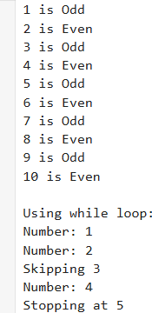

Demonstrate Recursive functions?

Programs:
def factorial(n): if n == 0:
return 1
return n * factorial(n - 1)

def fibonacci(n): if n <= 1:
return n
return fibonacci(n - 1) + fibonacci(n - 2) print("Factorial:", factorial(5))
print("Fibonacci Series:") for i in range(5):
print(fibonacci(i), end=" ")

Output:
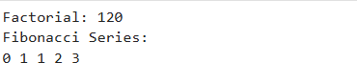

Demonstrate Lists?

Programs:
numbers = [10, 20, 30, 40, 50]

print("Original List:", numbers) print("First element:", numbers[0])

numbers.append(60) numbers.insert(2, 25)
numbers[1] = 22 numbers.remove(40) numbers.pop()

print("\nList elements:") for num in numbers:
print(num)

print("\nLength:", len(numbers)) print("Max value:", max(numbers)) print("Min value:", min(numbers)) numbers.sort()
print("\nSorted List:", numbers)

Output:
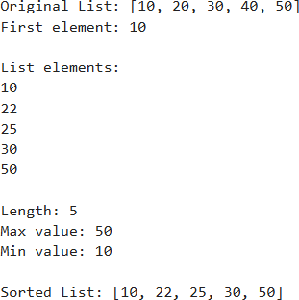

Demonstrate Tuples and Sets?

Programs:
tup = (10, 20, 30, 40)

print("Tuple:", tup) print("First element:", tup[0])
print("Count of 20:", tup.count(20)) print("Index of 30:", tup.index(30))

s = {1, 2, 3, 4, 4, 5}
print("\nSet:", s) s.add(6) s.remove(2)

s2 = {4, 5, 6, 7}
print("Union:", s.union(s2)) print("Intersection:", s.intersection(s2)) print("Difference:", s.difference(s2))

print("\nSet elements:") for i in s:
print(i)

Output:
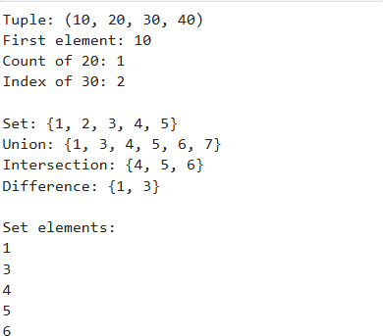

Demonstrate Dictionaries?

Programs:
student = {
"name": "Amrutha", "age": 20,
"course": "B.Tech"
}
print("Name:", student["name"]) student["marks"] = 85
student["age"] = 21

print("Updated Dictionary:", student)

Output:

Demonstrate inheritance and exceptional handling?

Programs:
class Person:
def init (self, name): self.name = name

def display(self): print("Name:", self.name)

class Student(Person):
def init (self, name, marks): super(). init (name) self.marks = marks

def show(self): print("Marks:", self.marks)

s = Student("Amrutha", 89) s.display()
s.show()

Output:
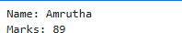

Demonstrate use of "re"?

Programs:
import re
text = "My phone number is 6301884326 and email is amruthavarshini@gmail.com" match = re.search(r'\d{10}', text)
if match:
print("Phone Number Found:", match.group())

numbers = re.findall(r'\d+', text) print("All Numbers:", numbers)

new_text = re.sub(r'\d{10}', 'XXXXXXXXXX', text) print("After Replacement:", new_text)

words = re.split(r'\s', text) print("Split Words:", words)

email = "amruthavarshini@gmail.com"
if re.match(r'^[\w\.-]+@[\w\.-]+\.\w+$', email): print("Valid Email")
else:
print("Invalid Email")

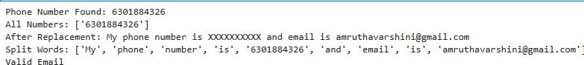
Output:

Demonstrate Aggregation?

Programs:
class Address:
def init (self, city, state): self.city = city
self.state = state

def display_address(self): print("City:", self.city) print("State:", self.state)

class Student:
def init (self, name, address): self.name = name
self.address = address

def display(self): print("Name:", self.name) self.address.display_address()

addr = Address("Raipur", "Chhattisgarh") s = Student("Amrutha", addr)
s.display()

Output:
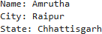

Demonstrate Indexing and Sorting?

Programs:
numbers = [50, 20, 40, 10, 30]
print("Original List:", numbers) print("\nIndexing:")
print("First element:", numbers[0]) print("Last element:", numbers[-1])
print("Elements from index 1 to 3:", numbers[1:4])

numbers.sort()
print("\nSorted (Ascending):", numbers)

numbers.sort(reverse=True) print("Sorted (Descending):", numbers)

new_list = sorted(numbers) print("Using sorted():", new_list)

Output:
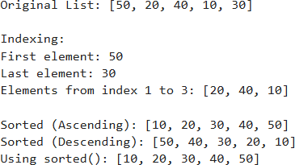

Demonstrate handling of missing data?

Programs:
import pandas as pd import numpy as np

data = {
'Name': ['A', 'B', 'C', 'D'], 'Age': [20, np.nan, 22, 21],
'Marks': [85, 90, np.nan, 88]
}

df = pd.DataFrame(data)

print("Original Data:") print(df)

print("\nMissing Values:") print(df.isnull())

df_drop = df.dropna()
print("\nAfter Dropping Missing Values:") print(df_drop)

df_fill = df.fillna(0)
print("\nAfter Filling Missing Values with 0:") print(df_fill)

Output:
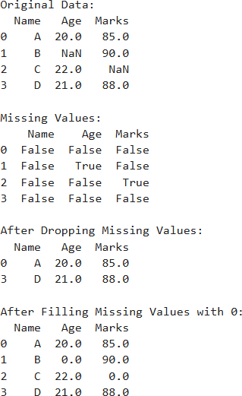

Demonstrate hierarchical indexing?

Programs:
import pandas as pd

data = {
"Name": ["Amrutha", "Shashwat", "Amrutha", "Shashwat"],
"Subject": ["Math", "Math", "Science", "Science"], "Marks": [85, 90, 88, 92]
}

df = pd.DataFrame(data)

print("Original DataFrame:") print(df)
df.set_index(["Name", "Subject"], inplace=True)

print("\nDataFrame with Hierarchical Index:") print(df)
print("\nMarks of Amrutha:") print(df.loc["Amrutha"])
print("\nMarks of Amrutha in Math:") print(df.loc[("Amrutha", "Math")])

df_reset = df.reset_index()

print("\nAfter Resetting Index:") print(df_reset)

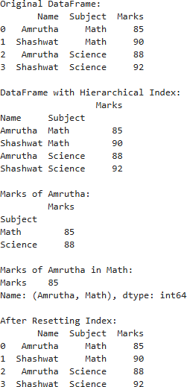
Output:

Demonstrate usage of Pivot table?

Programs:
import pandas as pd

data = {
"Name": ["Amrutha", "Shashwat", "Amrutha", "Shashwat", "Amrutha"],
"Subject": ["Math", "Math", "Science", "Science", "Math"], "Marks": [85, 90, 88, 92, 95]
}

df = pd.DataFrame(data)

print("Original Data:") print(df)

pivot = pd.pivot_table( df,
values="Marks", index="Name", columns="Subject", aggfunc="mean"
)

print("\nPivot Table (Average Marks):") print(pivot)

Output:
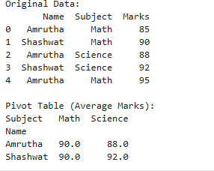

Demonstrate use of and queryo?

Programs:
import pandas as pd

data = {
"Name": ["Rishitha", "Amrutha", "Upendhar", "Shashwat"], "Age": [20, 22, 21, 23],
"Marks": [85, 90, 75, 88]
}

df = pd.DataFrame(data)

print("Original Data:") print(df)

filtered = df[(df["Age"] > 20) & (df["Marks"] > 80)]

print("\nFiltered using AND condition:") print(filtered)
query_result = df.query("Age > 20 and Marks > 80") print("\nFiltered using query():")
print(query_result)

Output:
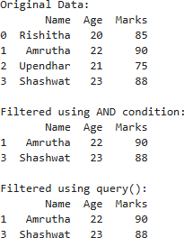

Demonstrate Scatter Plot?

Programs:
import matplotlib.pyplot as plt

x = [1, 2, 3, 4, 5, 6]
y = [2, 4, 1, 5, 7, 3]

plt.scatter(x, y)

plt.xlabel("X-axis") plt.ylabel("Y-axis") plt.title("Simple Scatter Plot")

plt.show()

Output:

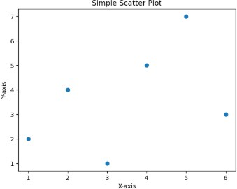

Demonstrate 3D plotting?

Programs:
import matplotlib.pyplot as plt
from mpl_toolkits.mplot3d import Axes3D
x = [1, 2, 3, 4, 5]
y = [2, 3, 4, 5, 6]
z = [5, 6, 7, 8, 9]
fig = plt.figure()
ax = fig.add_subplot(111, projection='3d') ax.scatter(x, y, z)
ax.set_xlabel("X-axis") ax.set_ylabel("Y-axis") ax.set_zlabel("Z-axis")

plt.title("3D Scatter Plot") plt.show()

Output:
